Hi, Subcontractor Name,

As part of a new initiative to improve our Subcontractor PQQ, tendering, and subcontract process, we’ll introduce the C-Link/Prosper Portal, a subcontract procurement management software.

The adoption and use of the C-Link/Prosper Portal at your company name will allow:

- One-time Completion and update of all your PQQ Requirements
- Quick submission and response to tender queries and quotations
- Issuance and signing of subcontract Orders.

As a valued member of our supply chain, you will be invited to register with C-Link/Prosper; registering and using the C-Link/Prosper Portal will be free.

From a subcontractor standpoint, once you have activated your Prosper account and created your password, Go to My Company > Prequalification area of your account and complete your PQQ Information.

Next Steps

You will receive an introduction email from The Prosper Team on the (XX/XX/202X) inviting you to activate your account (check Spam or Junk folders). Please watch out for and action this email.

See the introduction email example below.

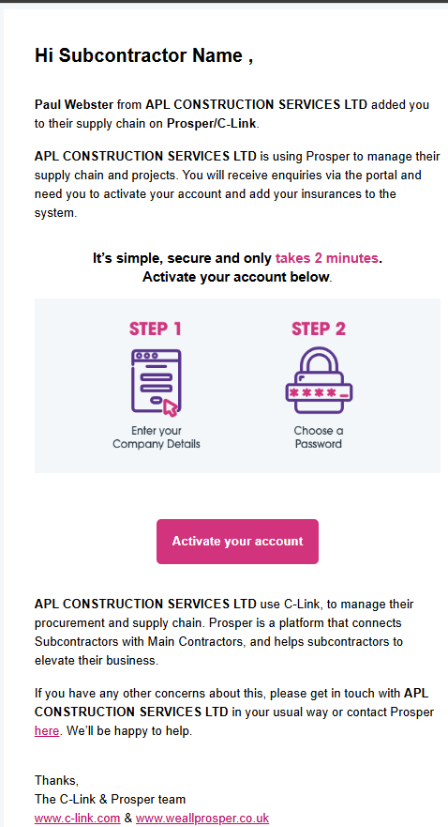

Please contact me if you have any queries concerning the above.

Kind regards,

Your Company Name

